**Task 2: Implementing Two-Factor Authentication (2FA)**

• **OBJECTIVE**

Task: Set up 2FA for your accounts.

Details:

Enable 2FA on personal accounts such as email and social media.

Use an authenticator app or hardware token for additional security.

• **STEPS**

**1: Access LinkedIn Settings:**

o Logged into my LinkedIn account and navigated to the **Settings & Privacy** section.

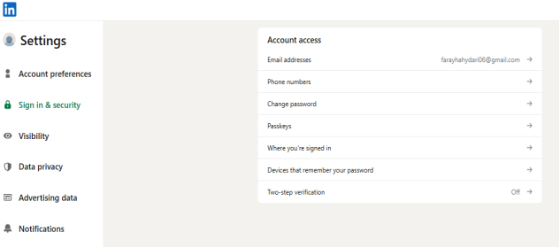

**2: Locate Two-Factor Authentication:**

• From the **Account** tab, I found the **Two-Step Verification** section and clicked on it.

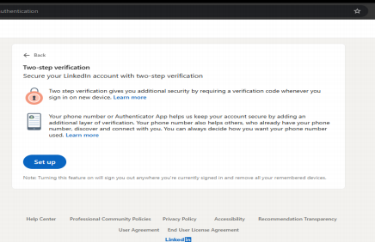

• If you have don’t one two-step verification, then you simply click step up.

**3: Begin the Verification Setup:**

• LinkedIn prompted me to verify my identity through the LinkedIn mobile app, confirming the update in account security

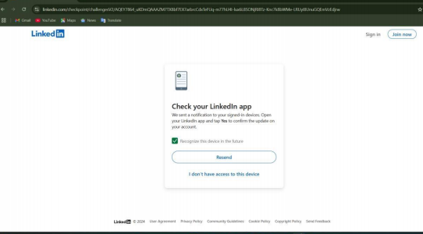

.**4: Select Authenticator App:**

• Once verified, I chose the **Authenticator App** option as my preferred method for 2FA.

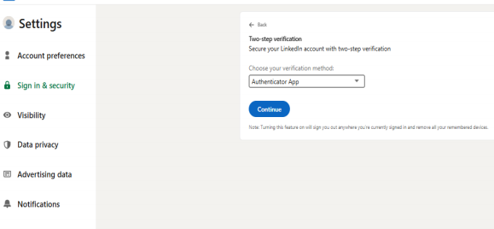

**5: Linking Authenticator App:**

• Opened my authenticator app (such as Google Authenticator or Microsoft Authenticator) and scanned the ǪR code provided by LinkedIn to add my LinkedIn account.

**6: Complete the Setup:**

• After successfully scanning the ǪR code, the authenticator app generated a time-based one-time password (TOTP), which I entered into LinkedIn to complete the 2FA setup process.

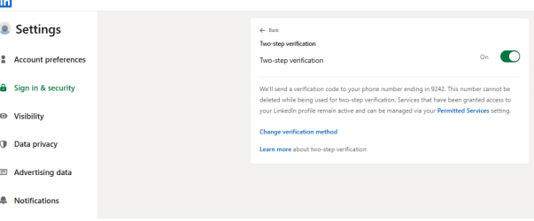

By completing this process, I ensured my LinkedIn account now requires both my password and a verification code from my authenticator app for secure login.